# IFB299 [Application Design and Development](https://blackboard.qut.edu.au/webapps/blackboard/execute/courseMain?course_id=_133113_1)

# Personal Portfolio

Group number: 37

Name: Fengchen Liu

Student number: N9326413

Group member: Louis Williams, Aaddy Sam, Justin Chen

## Role Based Artefacts in Release and Sprint plan One & Two

## First, User Stories brainstorming

At the start of our project, we wrote user stories to assume what are users requirements thereby to design what features and functionalities should be included in our projects. Five slides of user stories had been completed by me.

1. 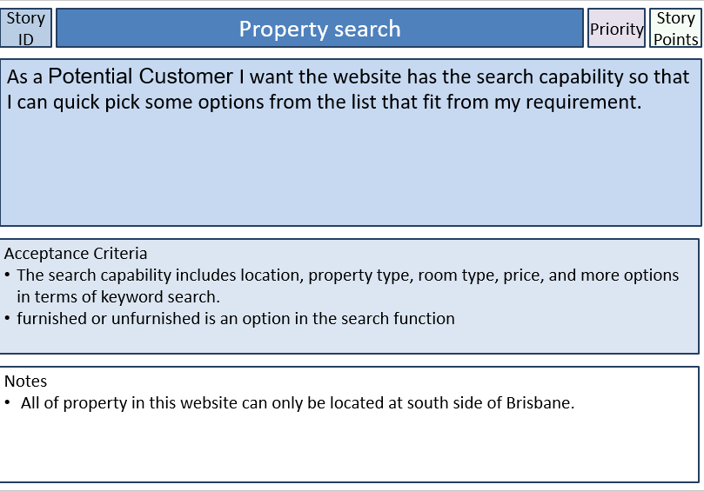
2. 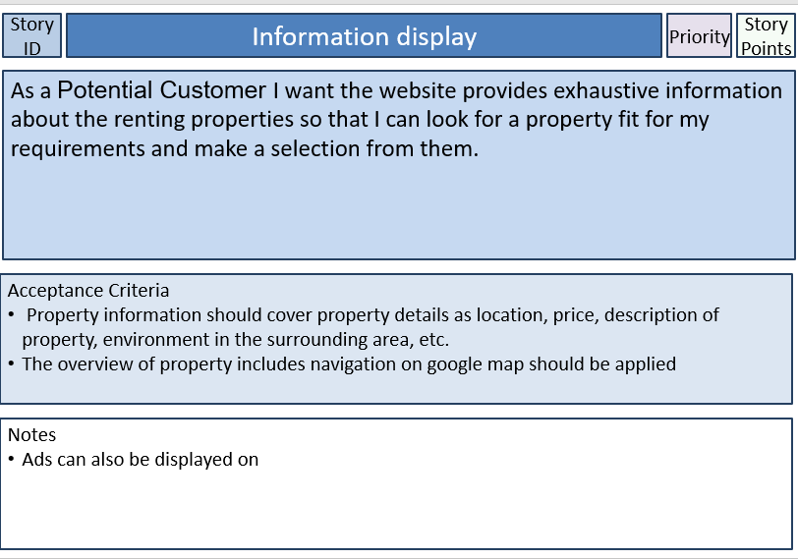
3. 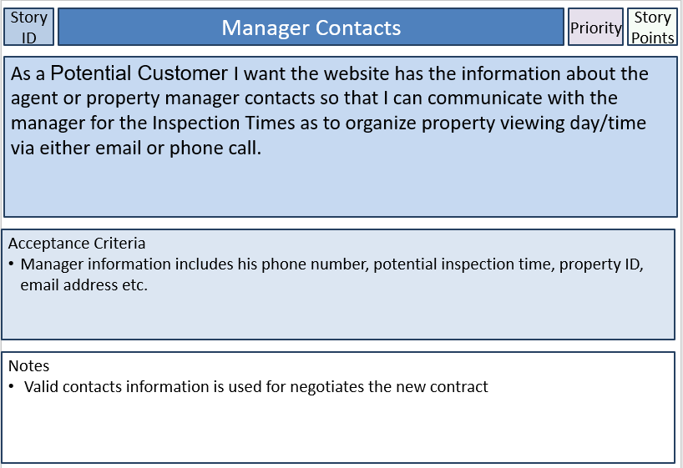
4. 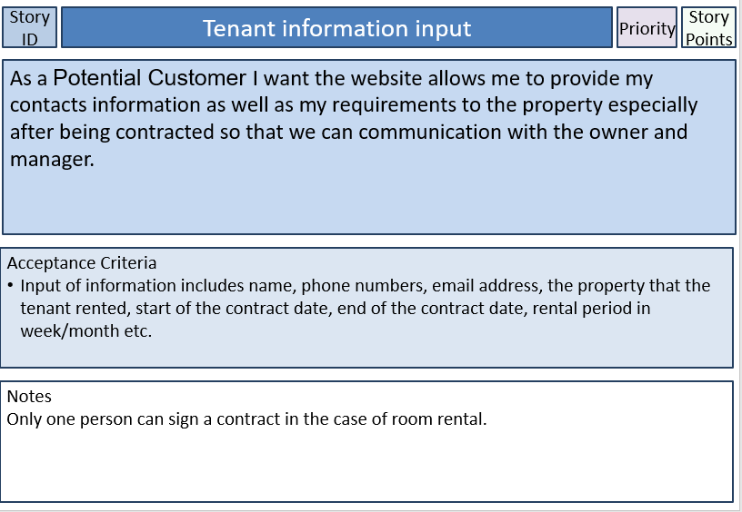
5. 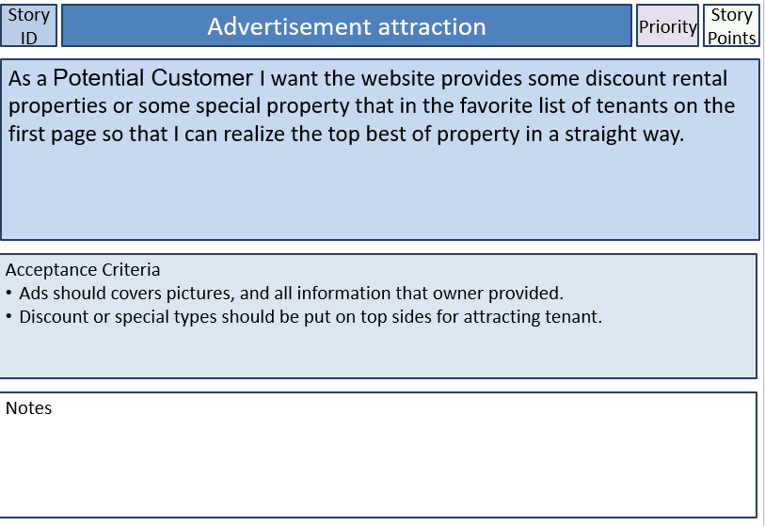

## Second, actual user stories design

And within the group meeting discussion, these user stories are the criterial for me to process the sprint and release plan as well as the code in development website. We combined our own stories and discuss more details should be covered in to each section, but Louis did all these writing.

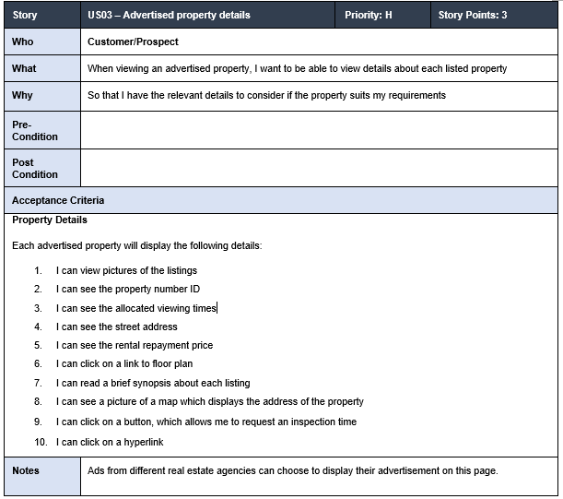

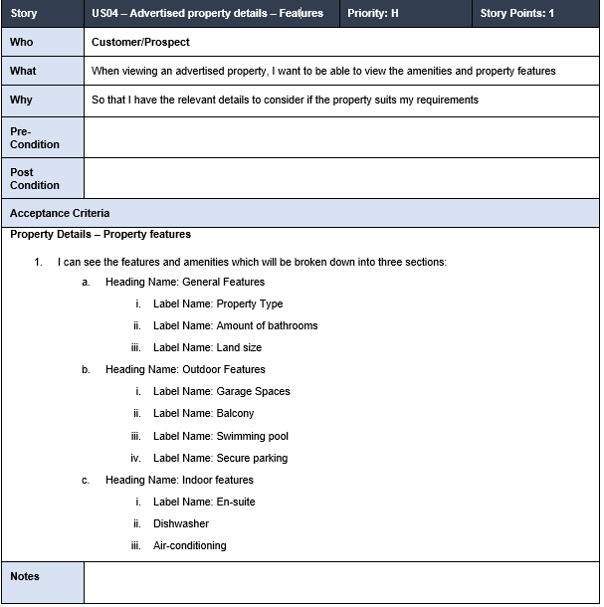

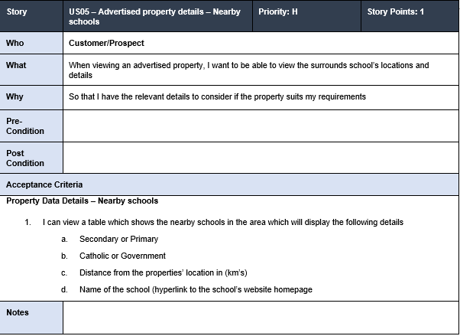

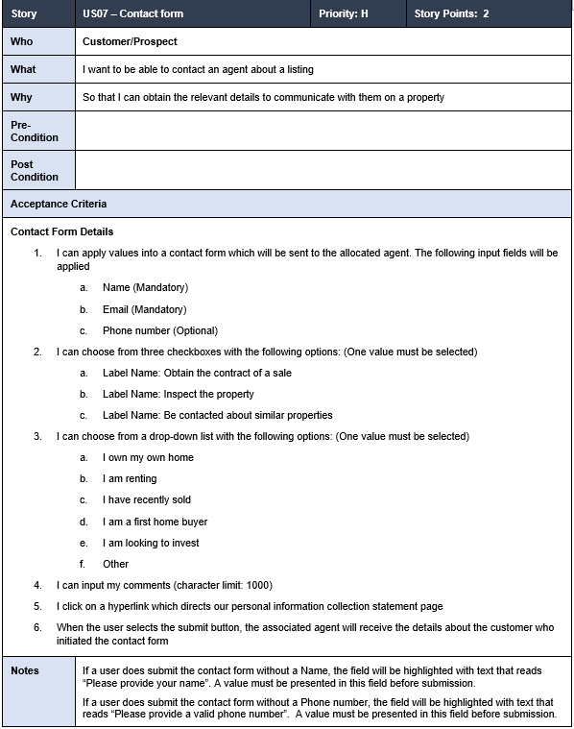

## Third and fourth, Release and sprint plan one & two

In the process of determine our release and sprint plan, Contact form and advertised property details are covered in sprint one, but at the end of sprint and release one, we found advertised property details have not enough time to complete, so we put it again into release two as to further develop.

*Sprint one;*

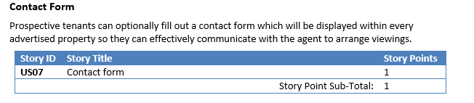

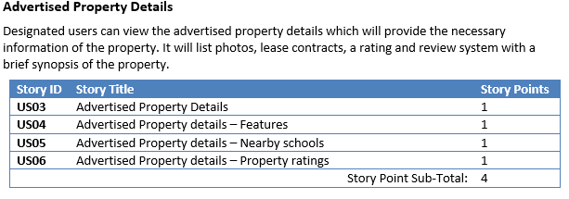

*Release one;*

Design what feature should be completed in release one for contact forma and estate time assume as well as real time taken recording.

Database parts cannot be completed due to I don’t have knowledge of this part. So I delete this section

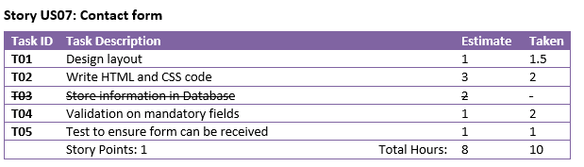

*Release two;*

Actual works that should be undertaken in release two for advertised property details.

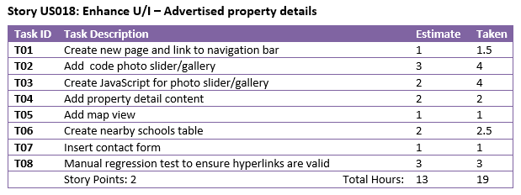

## Fifth and sixth, Coding for two release plan sections.

In release one, I have completed with contact form section.

Which is basic html code without Css, and Louis has done Css as the whole project background

**Overview of Contact form**

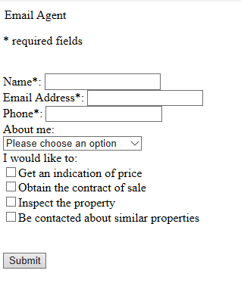

**Code design**

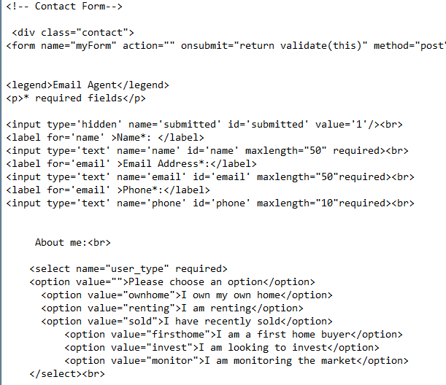

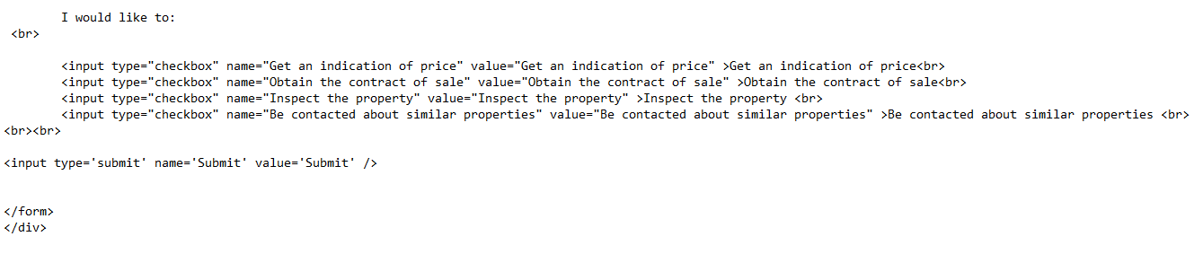

**Overview of advertised property details**

**Property photos gallery**

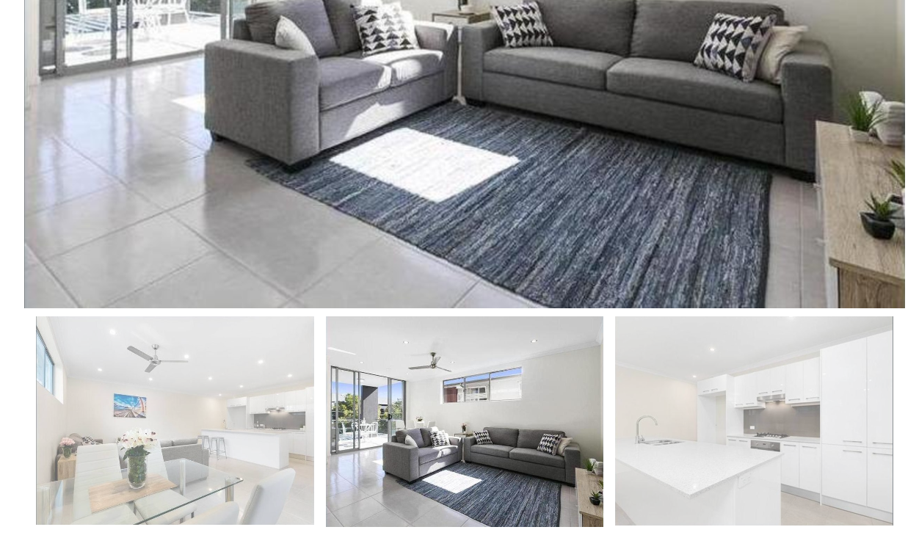

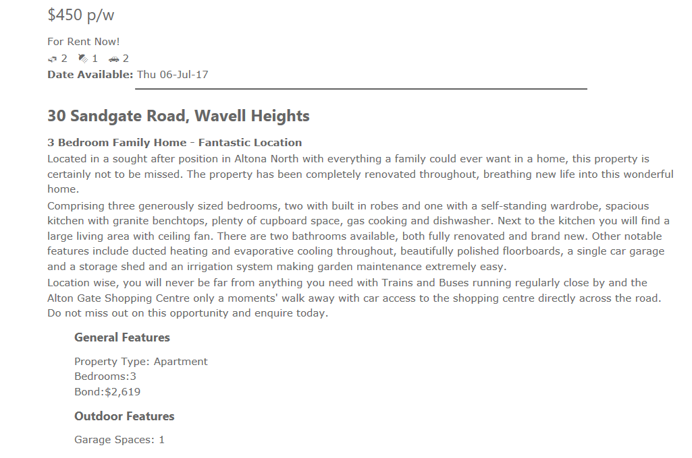

**Property details**

**Nearby school list and final contact form content**

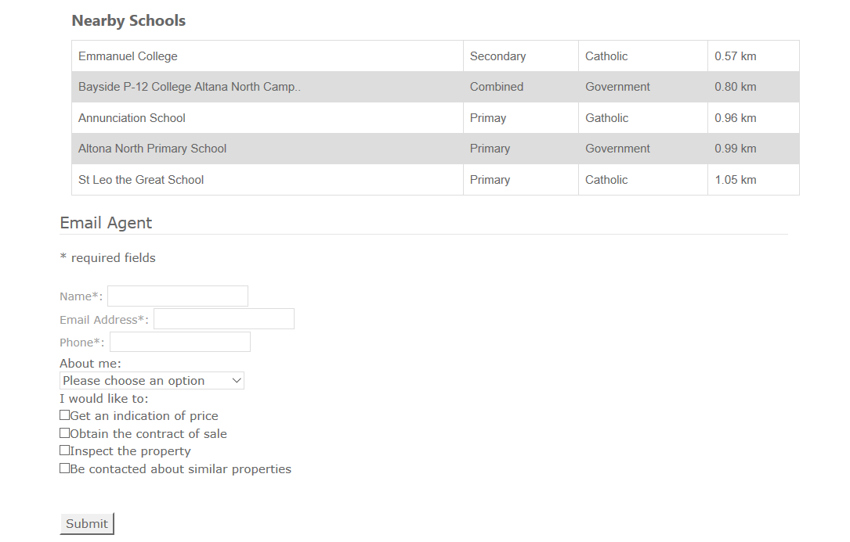

**Nearby school can link to a school site in a new tab**

**Code for property details**

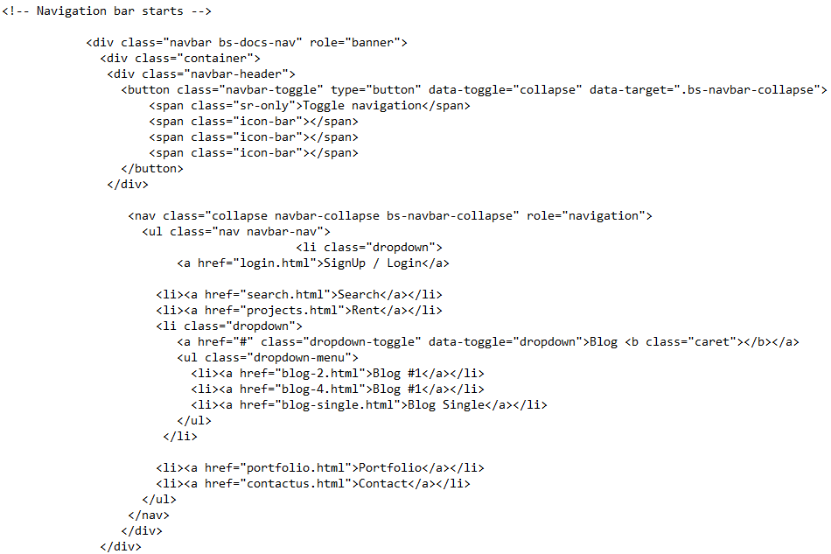

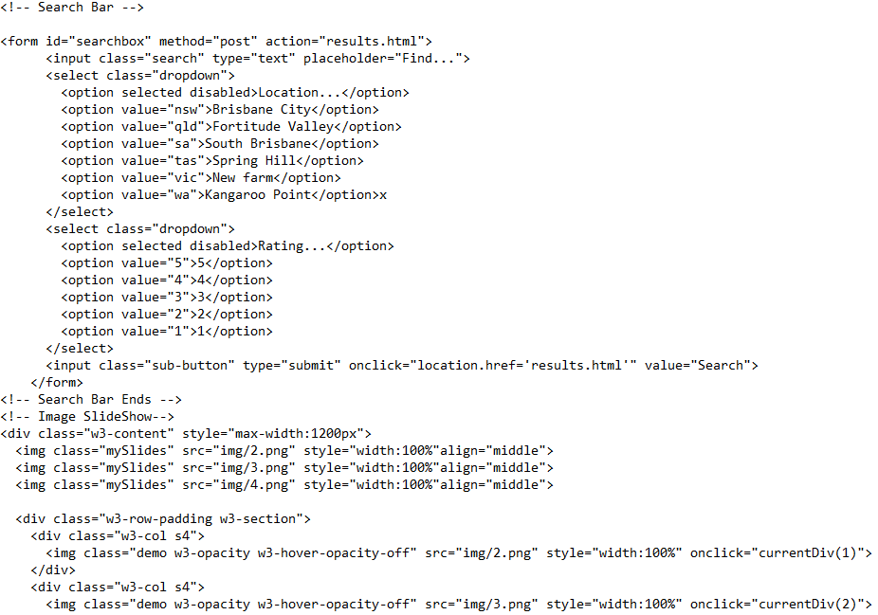

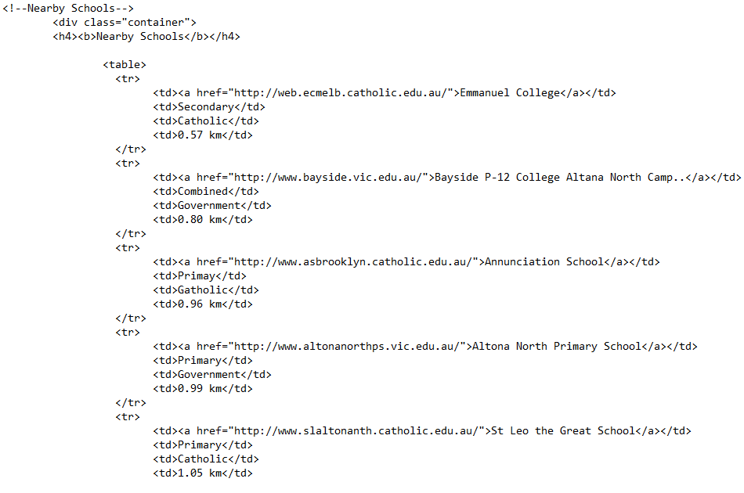

Thee code are the basic html stuff, and my group set up the css for the whole site.

## Seventh and eighth, Testcase for contact form and Property details

In the release plan one, I wrote a testcase to verify if the Submit functionality works. And testcase shows that Submit does not work because the database and PHP scripts are not being developed.

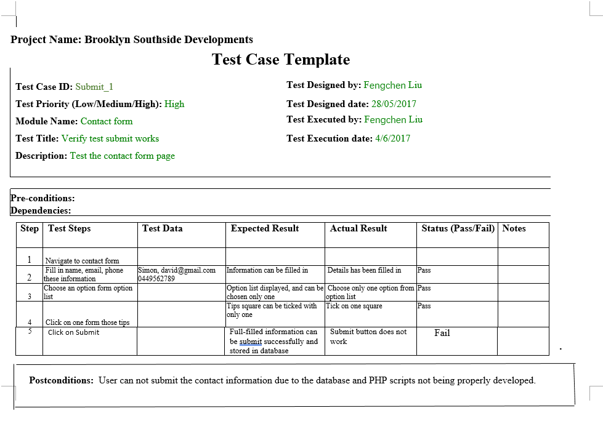

In release two, I wrote a testcase for verify if the hyperlinks work. The testcase shows that both of the hyperlinks in property details work properly.

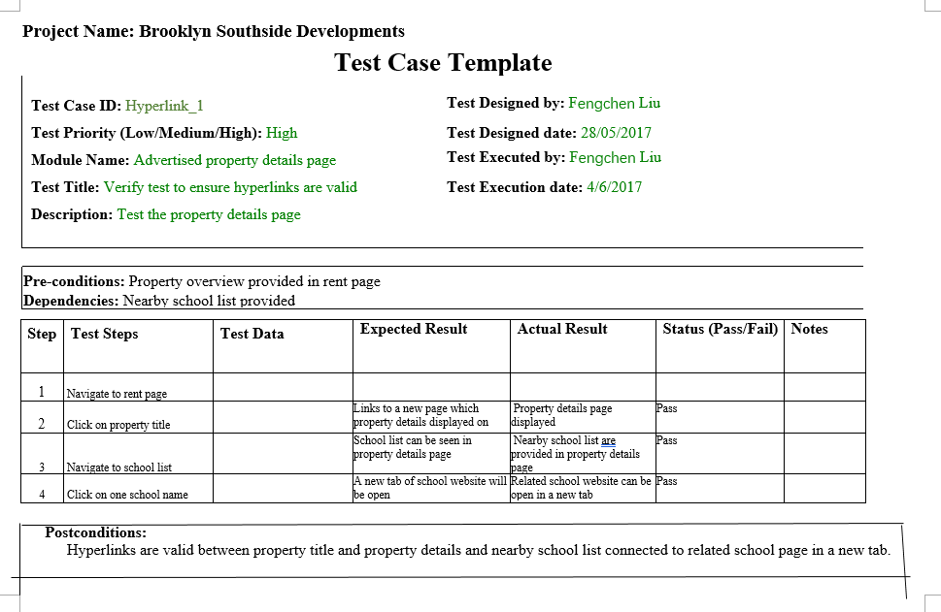

## Ninth, peer review & business letter

After the release and sprint plan one, we have developed our project basically with parts of features done, we have demonstrated to the other team, and they demonstrated to us as well. Aaddy Sam and me wrote a business letter as a feedback for their demonstration. 